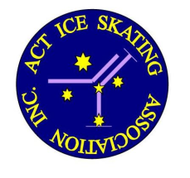
2017 Spring Competition
Aussie Skate Final Results

Basic 2

1 Miranda Stokes ACT

Novice 1

1 Ashlyn Edghill ACT

Novice 2

1 Luka Stokes ACT

Freeskate 1

1 Mikayla Geiger ACT

Freeskate 3

1 Aurelia Duncan ACT

Freeskate 4

1. Millie Raymond ACT
2. Isabella Van Den Bogaart ACT

Phillip Swimming & Ice Skating Centre
13 October 2017

