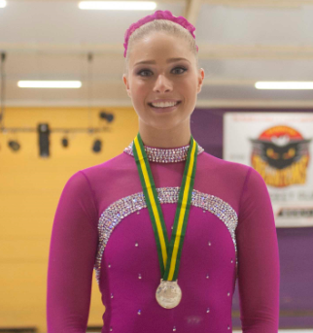 | 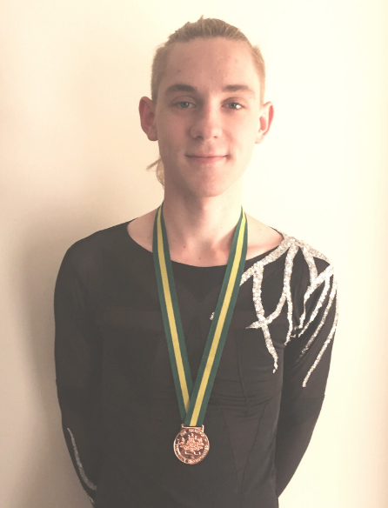
Josey wearing gold | Ben with bronze
Congratulations to all our skaters who represented ACTISA at the 2015 National competition.

A special mention must be made of our medallists Josey Kooyman who won gold in the Adult Gold event and Ben Meeuwissen who won a bronze in the Intermediate Men’s division.
Lauran Ashman had a wonderful skate to finish 4th in the Intermediate Ladies division.
Our gold medallist Josey began skating at the tender age of 3 and represented ACTISA at Nationals for a number of years until injury and other interests kept her from the rink.
When asked what has brought her back to skating as a young adult, Josey had a long list that included fitness, friendships formed while training, and the thrill of competing. At the top, however, was the opportunity to take part in shows such as Skate in the City.
The adult divisions offer skaters an opportunity to continue completive skating for many years after retiring from elite divisions. Josey can be rightly proud of her achievement and we hope she will continue to represent ACTISA for many years in the future.

